Day 6: Fully Stocked

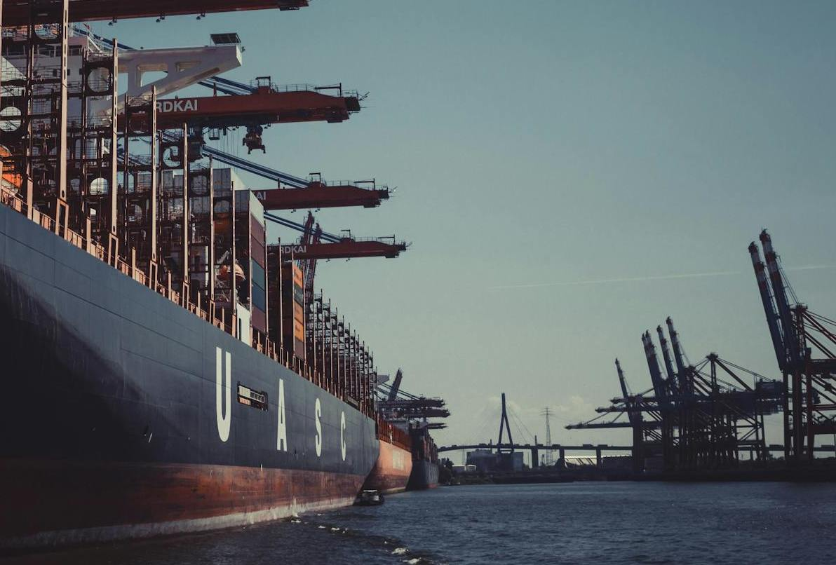

*Container vessels are a common sight in ports around the world, but this one is particularly well-stocked. They're a vital part of the global supply chain, but where is this one moored?*

*In which city would you find this port?*

I start by doing a Google Reverse Image search. This brings about many exact matches. I decide to search for only the right side of the picture, thus removing the ship. This results in a number of similar images. One result from Flickr seems a good match and it mentions Hafen Hamburg (see below). Zooming into the picture reveals the same bridge and other structures. Therefore, my answer is:

**Hamburg**.

